HematoVision: Advanced Blood Cell

Classification - Comprehensive Project Document

Executive Summary
This document provides a comprehensive overview of the HematoVision project, an AIpowered system designed for the accurate and efficient classification of blood cells. Leveraging advanced deep learning techniques, particularly transfer learning with pretrained Convolutional Neural Networks (CNNs), HematoVision aims to address the critical need for automated blood cell analysis in medical diagnostics. This report synthesizes information from various project documents, including problem statements, ideation, solution requirements, technical architecture, customer journey maps, and project planning details, to present a holistic view of the project from conception to proposed implementation.

Project Overview
HematoVision is a web-based application developed to assist pathologists and healthcare professionals in the analysis of blood cell images. The project's core objective is to provide a reliable, scalable, and user- friendly tool that reduces the manual workload, minimizes human error, and accelerates diagnostic processes associated with traditional blood cell classification. It also serves as an educational resource
for medical training.

  - Project Details
S66117

Problem Definition

Core Problem
The accurate identification and classification of blood cells are critical for diagnosing various hematological disorders. However, manual microscopic analysis of blood smears is time-consuming,
labor-intensive, and prone to human error due to variability in expertise and fatigue. Existing automated systems often lack the precision and robustness needed to handle diverse blood cell types and
abnormalities under varying imaging conditions.

Problem Validation
Evidence for this problem is abundant, with numerous research efforts focused on automating blood cell classification and the availability of large public datasets specifically for this task. The manual process leads to inaccurate or delayed diagnoses, impacting patient outcomes and increasing healthcare costs.
Therefore, an advanced, automated system is critically needed.

Ideation and Brainstorming

Brainstorming Key Ideas
Initial brainstorming for HematoVision focused on:

    - Developing a deep learning model for image classification.

    - Utilizing transfer learning to leverage pre-trained models for efficiency and accuracy.

    - Building a web-based interface for easy access.

    - Focusing on common blood cell types (Eosinophil, Lymphocyte, Monocyte, Neutrophil).

    - Considering integration with existing clinical workflows.

Empathy Mapping
An empathy map was utilized to understand the user's (hematologist/pathologist) behaviors and attitudes. This tool helped in considering the user's perspective, goals, and challenges, ensuring the solution is user-centric.

Solution Requirements

Functional Requirements
Functional requirements define the specific actions the HematoVision system must perform:

    - User Management: User registration (email, social media), login, and password recovery.

    - Image Upload and Management: Allow users to upload blood cell images (JPEG, PNG), validate them, securely store them temporarily, and delete them after processing.

    - Blood Cell Classification: Preprocess images, classify blood cells into predefined categories (Eosinophil, Lymphocyte, Monocyte, Neutrophil), provide confidence scores, and integrate a pre-
trained machine learning model.

    - Result Presentation: Display classification results, including predicted cell type and confidence, with potential visual feedback and future historical result viewing.

Non-Functional Requirements
Non-functional requirements specify the quality attributes of the system:

    - Performance: Response time (5-10 seconds), scalability for concurrent users, and high throughput.

    - Security: Data privacy, secure authentication and authorization, and data encryption (HTTPS).

    - Usability: Intuitive and user-friendly interface, accessibility, and informative error messages.

    - Reliability: High uptime (99.9%), data integrity, and fault tolerance.

    - Maintainability: Modular architecture, high code quality, and testability.

    - Portability: Platform independence and use of widely supported open-source technologies.

Technical Architecture and Tech Stack

High-Level Architecture
HematoVision follows a client-server architecture. A web-based frontend interacts with a Python-based backend that hosts the machine learning model. The core components include:

    - Client-Side (Web Browser): User interface (HTML, CSS, JavaScript) for image upload and result display.

    - Web Application Backend (Flask): Handles user requests, manages image uploads, and orchestrates interactions with the ML model.

    - Machine Learning Model (TensorFlow/Keras): The trained deep learning model responsible for blood cell classification.

    - Storage: Local filesystem for temporary storage of uploaded images.

Detailed Tech Stack
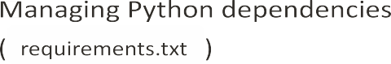

  - Machine Learning Model Details

    - Architecture: Fine-tuned MobileNetV2 Convolutional Neural Network.

    - Dataset: 12,500 augmented blood cell images from Kaggle.

    - Training: 5 epochs, Adam optimizer, categorical cross-entropy loss.

    - Accuracy: Approximately 85.3% validation accuracy.

    - Model Persistence: Saved as blood_cell.h5 for deployment.

Customer Journey Map
The customer journey for HematoVision involves several stages, primarily for pathologists and healthcare professionals:
- Sample Acquisition: Pathologist receives a blood sample (manual, time-consuming).

- Image Capture: Pathologist captures digital images of blood cells using microscopy equipment.

- Image Upload: User uploads images to the HematoVision web application ( home.html ).

- Image Processing and Classification: The backend ( app.py ) processes the image using the ML model ( model.ipynb ).
- Result Display: Classification results are presented to the user on result.html .

Project Planning and User Stories

Product Backlog and Sprints
The project planning adheres to agile methodologies, with a product backlog organized into functional epics and user stories with estimated story points and priorities. The development is structured into sprints.

  - Key User Stories (Customer - Mobile User)

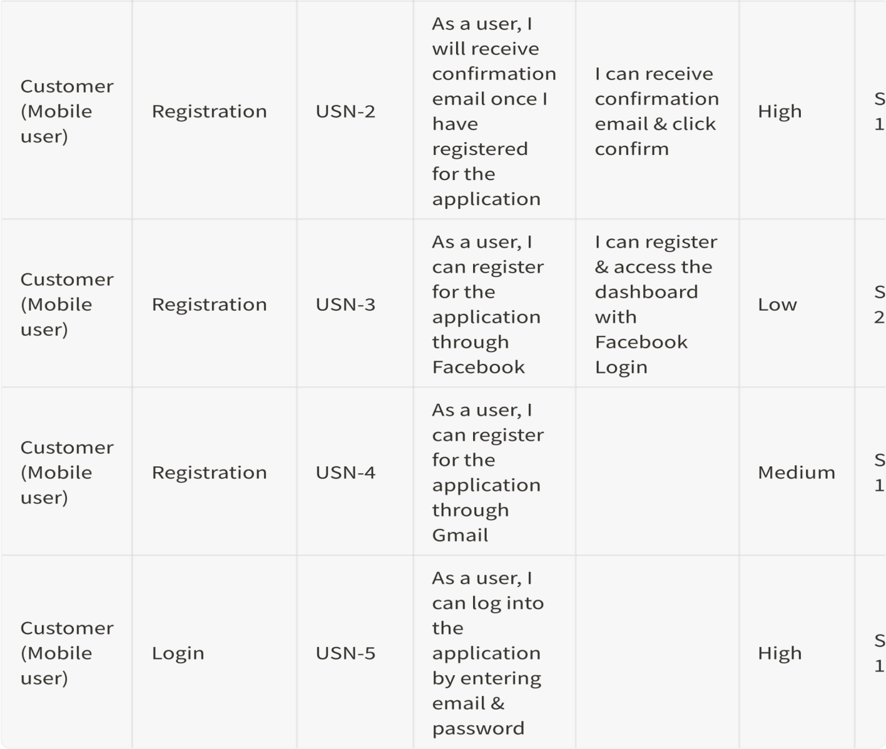

Problem-Solution Fit Analysis

Alignment
HematoVision directly addresses the core problem of inefficient and inaccurate manual blood cell classification by providing an automated, AI-driven alternative. It targets pain points like time
consumption, human error, and the need for specialized expertise. The solution is highly desirable for pathologists as it saves time, reduces errors, improves workflow, and enhances diagnostic confidence.

Value Proposition Clarity
The value proposition is clear and compelling: "Accurate and efficient blood cell classification using AI, leveraging transfer learning for enhanced precision and reduced analysis time." Users can easily
understand the benefits of faster, more accurate, and consistent blood cell analysis.

Feasibility & Viability

    - Technical Feasibility: The solution is technically feasible, leveraging established deep learning
techniques (transfer learning with MobileNetV2) and a widely used web framework (Flask). The provided model.ipynb and app.py demonstrate the viability.

    - Economic Viability: The solution has strong potential for economic viability by reducing labor costs, improving throughput, and potentially leading to earlier and more accurate diagnoses.

    - Risks and Assumptions: Potential risks include data bias, generalization issues, regulatory approval processes, integration challenges with existing systems, and user adoption hesitancy.

Next Steps
Further validation is needed through prospective clinical validation, User Acceptance Testing (UAT), performance benchmarking, and robustness testing. Key metrics to track include diagnostic accuracy,
turnaround time, user satisfaction, cost savings, and error rate reduction. Action items involve expanding the dataset, model refinement, feature enhancement, regulatory pathway planning, pilot programs, and scalability assessment.

Conclusion
HematoVision represents a significant advancement in automated blood cell analysis. By integrating cutting-edge machine learning with a user-friendly web interface, the project offers a robust, efficient, and scalable solution to a critical medical need. The comprehensive planning and detailed architectural design ensure a solid foundation for development, promising a valuable tool for healthcare professionals and a significant contribution to the field of medical diagnostics.

